Material 1 – The concept of culture: from a personal idea to a definition.
Tools:
Autobiography of intercultural encounters. Council of Europe, Strassbourg, 2009. (AIE)
Developing and assessing intercultural and communicative competence. Council of Europe, Graz, 2007. (ICCintE)
Enseignement précoce des langues modernes par des contenus. Council of Europe, Graz, 2011. (EPLC)

Why ? | Aims and contents  The activities will aim for students to:  - explore who they are,  - reflect on their culture-bound upbringing,  - analyse in depth their norms, values, beliefs and behaviour (as a first step towards accepting, understanding and enjoying otherness),  - develop further their sense of identity,  - become more aware that their culture influences their way of viewing the world, making decisions and interacting with others,  - become more aware of the fact their perspective is rooted and therefore limited,  - define concepts such as ‘identity’ and ‘culture’,  - interpret, analyse and discuss these concepts  Targeted competences  - I can understand the formation of my own experience, opinion, and attitudes. (Developing and assessing intercultural and communicative competence ICCintE),  - I can better understand my own cultural identity and how it is formed. (Developing and assessing intercultural and communicative competence),  - I can develop a system of interpretation which enables me to perceive the particular characteristics of culture (meanings, beliefs, cultural practices..). (CARAP/FREPA, skills, S-1.10).
What ? | Concepts and definitions of culture
How ? | The following activities and methods are suggested:  - Individual work - teacher trainees think of one element in their life that they would consider as a part of their culture.  - Discussion - participants share their ideas.  - Pair or group work - participants create a mind map or a poster around the concept ‘culture’.  - Discussion - participants attempt to create a common definition of culture.  - Pairs or small groups receive an existing definition of culture.  They compare their definition with existing definitions (see next page)  - Discussion – participants adjust the previous definition  (if needed).
Product ? | Definition(s) of culture for reference use during their stay in the hosting country (which can be adjusted if need be).
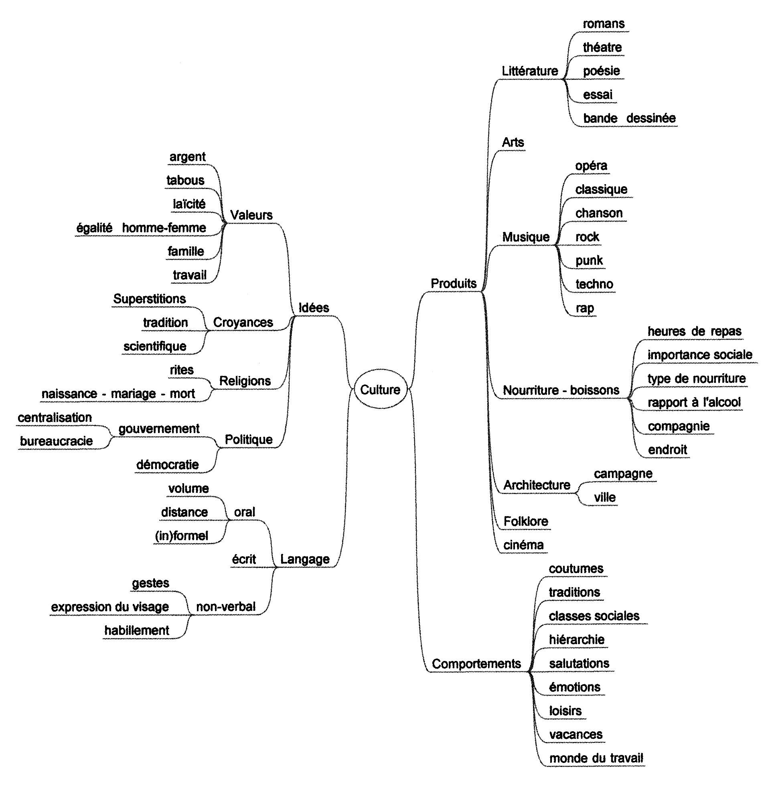
Enseignement précoce des langues modernes par des contenus (EPLC), Graz, ECML,2011
EPLC workshop (PP – slides 7-8)
See also…
Developing and assessing intercultural and communicative competence. Council of Europe, Graz, 2007. (ICCintE): Defining culture and Culture, p. 7
http://archive.ecml.at/mtp2/Iccinte/results/en/theoretical-background.htm
Autobiography of intercultural encounters: Concepts for discussion p. 3 / context, concepts and theories p. 6-8 http://www.coe.int/t/dg4/autobiography/Source/AIE_en/AIE_concepts_for_discussion_en.pdf

